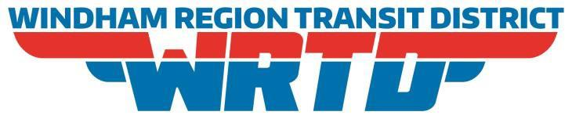
Public Hearing of the Windham Region Transit District at 5:30 p.m. February 23, 2022.
WRTD Board Room, 28 South Frontage Road, Mansfield Center, CT
Agenda
- Introductions
- Presentation
- Public Comment
- Adjourn
Join us in person or on Zoom!

Topic: Public Hearing - Route Changes, Proposed
Time: Feb 23, 2022 05:30 PM Eastern Time (US and Canada)

Join Zoom Meeting
https://us06web.zoom.us/j/82735258886
Meeting ID: 827 3525 8886
One tap mobile
+13126266799,,82735258886# US (Chicago)
+16465588656,,82735258886# US (New York)
Dial by your location
+1 312 626 6799 US (Chicago)
Meeting ID: 827 3525 8886
Find your local number: https://us06web.zoom.us/u/kbgHcJQ2it

